SETTING UP APPLICATION ENVIRONMENT TEAM ID:PNT2022TMID39173

Create flask project:

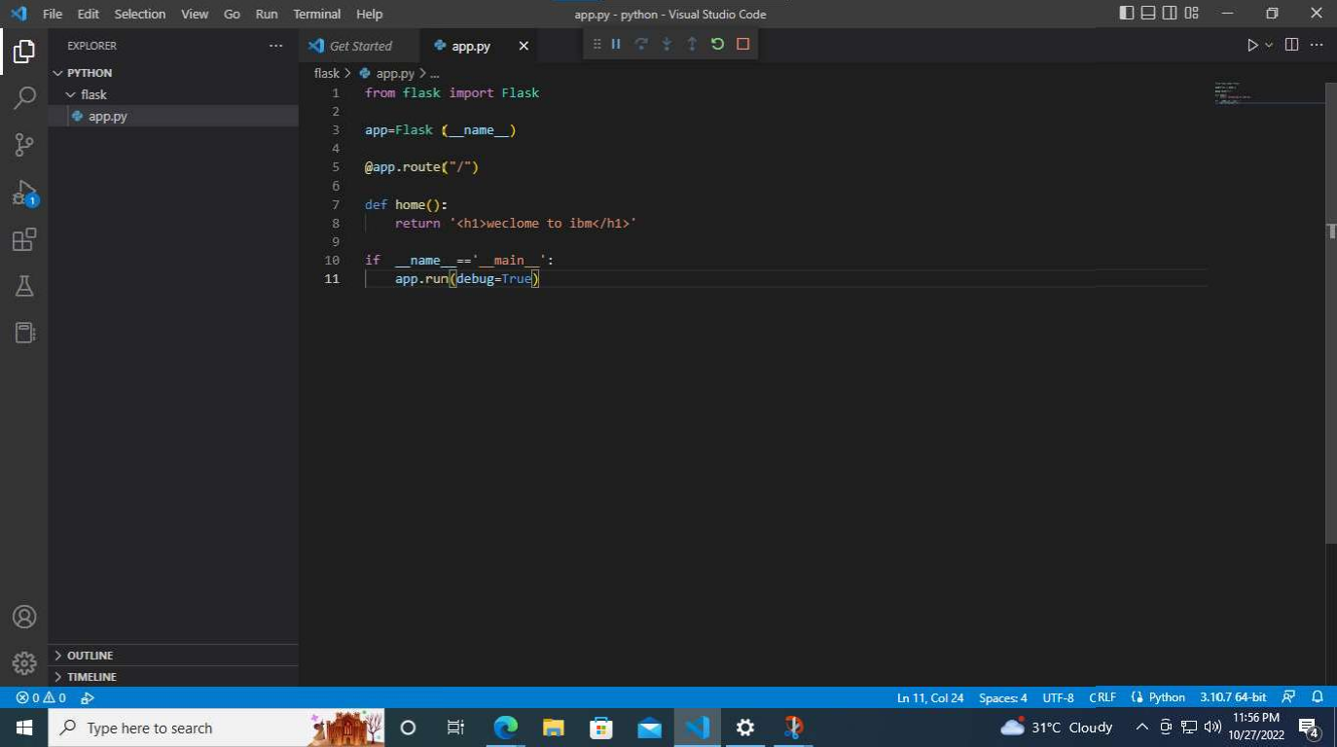

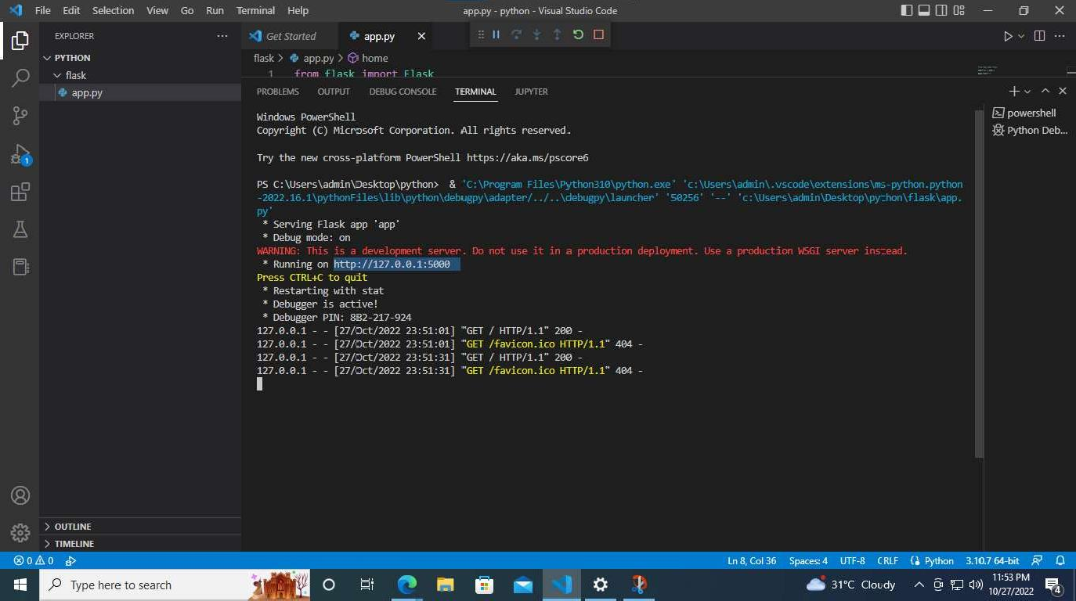Flask:

Output for flask:

